Abstract for IEEE NMDC 2021, October 17-20, 2021, Vancouver (Canada) (place your title here, Times New Roman 14, bold, centered)

- Firstauthor¹, Member IEEE B. Secondauthor², C. Thirdauthor¹, D. And So On²
(Names, Times New Roman 11, normal, centered. Presenting author underlined)

¹University of Victoria, Victoria, Canada
²North Carolina State University, Raleigh, North Carolina, USA
(Affiliation, Times New Roman 10, italic, centered)

Single-page abstracts should be submitted to IEEE NMDC 2021 by April 15th, 2021.

The required styles illustrated in this document can be used as a template for producing the abstract, replacing the relevant text with your own. The submitted file must be a pdf document.

The abstract of the contributed papers must be in English and should report previously unpublished work.
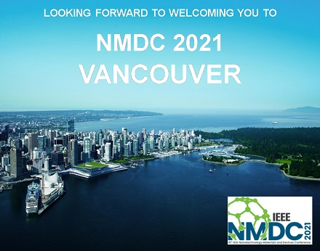
Figure 1. IEEE Nanotechnology Materials and Devices Conference 2021.

The abstract should be typewritten for A4 (210 × 297 mm) or Letter (215.9 × 279.4 mm) format paper, single column. Top and bottom margins should be set to 2.5 cm, left and right margins to 2 cm. Single-line spacing should be used.

Papers may include figures and tables. A caption should be written under each figure and above each table.

Fonts must be:
Title: Times New Roman 14, Bold, centered
Authors names: Times New Roman 11, normal, centered
Affiliations: Times New Roman 10, Italic, centered
Main text: Times New Roman 11, justified.
Figures and tables caption: Times New Roman 10, normal
Acknowledgments: Times New Roman 10, normal
References: Times New Roman 11, normal

Equations must be centered and numbered on the right as the following one:

K(t) = a exp(-b/t) (1)

List and number all references at the end of the Abstract. When referring to them in the text, type the corresponding reference number between brackets as shown at the end of this sentence [1].

Acknowledgments: Times New Roman 10

[1] We. Hope, T.O. See You, N. Ext October, I.N. Vancouver, You Enjoy, 17, 10 (2021).

