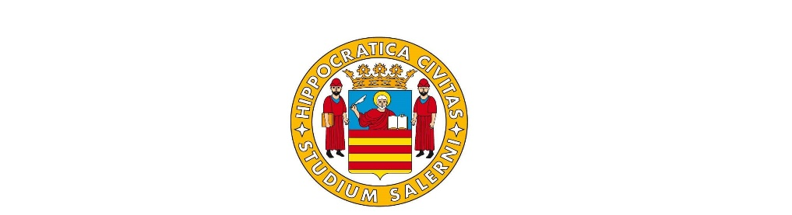
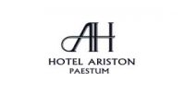
HOTEL RESERVATION FORM
IEEE NMDC CONFERENCE- OCTOBER 22nd – OCTOBER 26TH , 2023
SURMANE ____________________________ NAME____________________________________________
ARRIVAL DATE _______________________ DEPARTURE DATE __________________________________
NUMBER OF NIGHTS_________________ PHONE NUMBER_______________________________________
E-MAIL_________________________________________________________________________________
RECEIPT ADDRESS_____________________________________ ___________________________________
CITY__________________________________NOTE ____________________________________________
TYPE OF ROOM : DOUBLE SINGLE USE DOUBLE/TWIN TRIPLE DELUXE
TREATMENT OF BED AND BEAKFAST
IN DOUBLE SINGLE USE ( 1 PERSON ) € 110,00 PER NIGHT
IN DOUBLE ROOM ( 2 PERSONS ) € 130,00 PER NIGHT
IN TRILE ROOM ( 3 PERSONS ) € 170,00 PER NIGHT
IN DOUBLE DE LUXE ROOM ( 2 PERSONS ) € 240,00 PER NIGHT
PLEASE SEND A COPY OF YOUR PASSPORT OR IDENTITY CARD FOR REGISTRATION
NAME OF OTHER PEOPLE IN THE ROOM ( IF DOUBLE OR TRIPLE ) WITH DATE OF BIRTH AND PLACE OF BIRTH
_______________________________________________________________________________________
PLEASE INFORM US OF ANY ALLERGIES_____________________________________________________
To confirm the reservation we require Credit card number and expire date ( only to guarantee the reservation ) or Deposit by bank transfer of first night to be send to our bank
BANCA UNICREDIT IBAN IT 23 H 02008 76021 000500090640-
SWIFT CODE UNCRITM 16 44 – Account of HOTEL ARISTON S.r.l.
TYPE OF CREDIT CARD___________________EXPIRE DATE_______________________________________
NUMBER _______________________________________________________________________________
Cancellation is possible with no charge until one week before arrival date
PLEASE SEND THIS FORM BY E MAIL TO info@hotelariston.com AND WE WILL CONFIRM YOUR RESERVATION
Date _____________________________________SIGNATURE _______________________________
All data entered will be processed by the individual structures only for the purpose of guaranteeing the correct procedures relating to hotel bookings, in observance of the conditions dictated by Legislative Decree no. 196/2003 on Privacy. Sending this form implies the reading and acceptance of the rates, payment and cancellation methods relating to the Hotel where this reservation is made and indicated in the document

